**Project Design Phase-II**

**Solution Requirements (Functional & Non-functional)**

|  |  |
| --- | --- |
| Date | 15 October 2022 |
| Team ID | PNT2022TMID41308 |
| Project Name | Project – SMART WASTE MANAGEMENT FOR METROPOLITAN CITIES |
| Maximum Marks | 4 Marks |

**Functional Requirements:**

Following are the functional requirements of the proposed solution.

|  |  |  |
| --- | --- | --- |
| **FR No.** | **Functional Requirement (Epic)** | **Sub Requirement (Story / Sub-Task)** |
| FR-1 | Communicate and exchange information to provide server for user | To detect level of bins  Weight of bins  Alert the authorized person |
| FR-2 | Live asset monitoring | Track the bins and truck location  Waste collection status  Bins fill level monitor |
| FR-3 | User requirement | Promote health care service  Pollution prevention  Improve efficiency |
| FR-4 | Mandatory | Reduce traffic and fuels  Reduce running cost  Safe disposal of waste  Avoid health hazard |
| FR-5 | Captured in use case | (image) |
| FR-6 | Testing  Empty(T1)  Medium(T2)  Nearly full(T3)  Full (T4)  Threshold crossed(T5) | The test case status is pass if  T1⟶null  T2⟶intermediate level  T3⟶above the threshold level  T4⟶maximum level  T5⟶spill over |

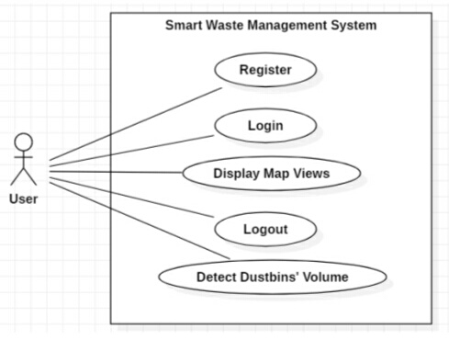

**Non-functional Requirements:**

Following are the non-functional requirements of the proposed solution.

|  |  |  |
| --- | --- | --- |
| **FR No.** | **Non-Functional Requirement** | **Description** |
| NFR-1 | **Usability** | High usability of user experience design for user, which is to solve the problem efficiently. |
| NFR-2 | **Security** | The system an only accessed by authorized person. |
| NFR-3 | **Reliability** | Identifying the problem and providing clear solution for it, by accurate real time data collection. |
| NFR-4 | **Performance** | The performance should effective and efficient. |
| NFR-5 | **Availability** | The existing system affects the garbage collector due to climate change and indirectly affects the people health care. |
| NFR-6 | **Scalability** | The system should have upgradable feature. |